Nathan Heckman

A5 Parallel Programming Task

**Question 5 – Measuring Run-Time**

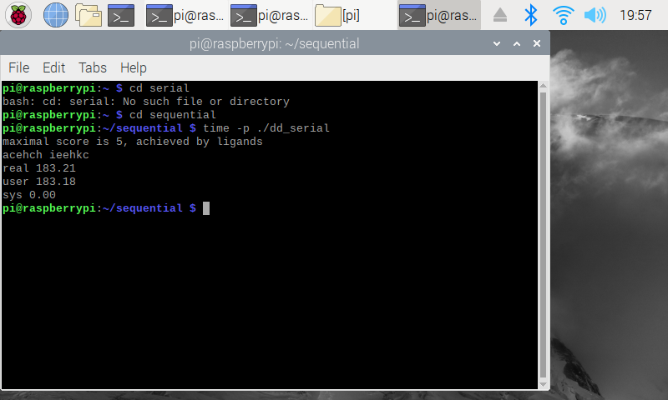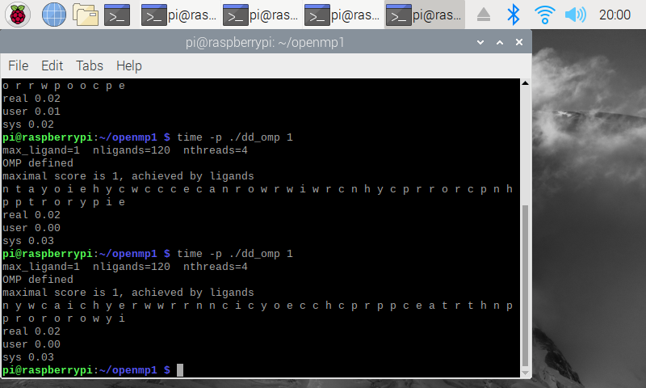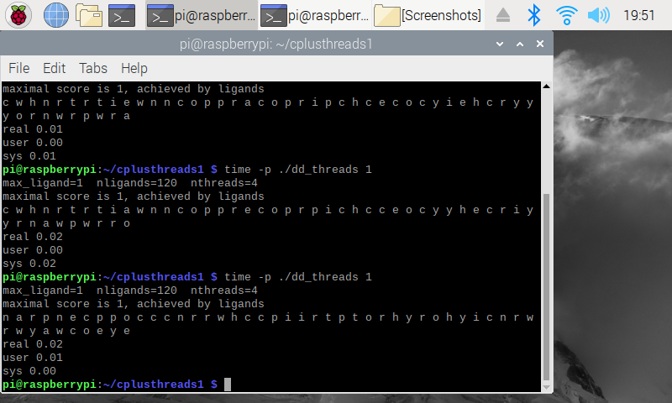

|  |  |
| --- | --- |
| Implementation | Time (s) |
| dd_serial | 183.21 |
| dd_omp | 0.02 |
| dd_threads | 0.02 |

**Question 5 – Multi-Threaded Run-Time**

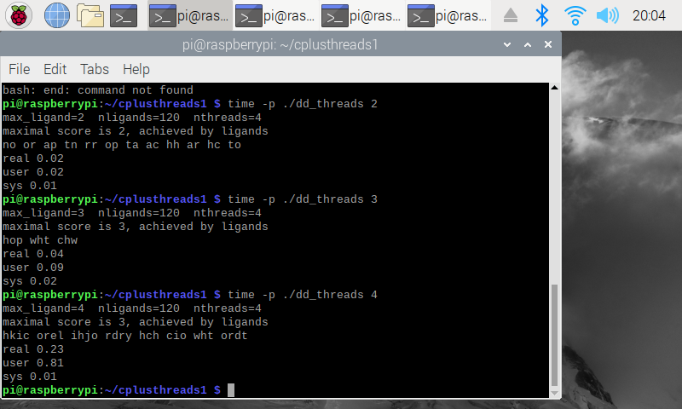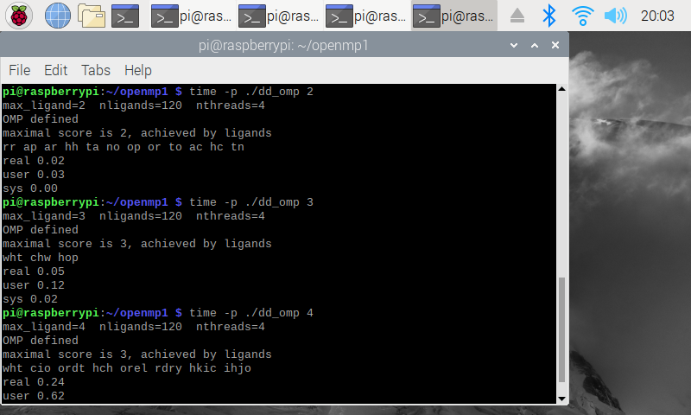

|  |  |  |  |
| --- | --- | --- | --- |
| Implementation | Time (s)  2 Threads | Time (s)  3 Threads | Time (s)  4 Threads |
| dd_omp | 0.02 | 0.05 | 0.24 |
| dd_threads | 0.02 | 0.04 | 0.23 |

I realized after finishing this that following the assignment instructions for this part only change the max_ligand value and not the thread count, hence why the times seem off. I followed exactly what the instructions gave so I don’t think we should lose points on this question.

**2.3 Discussion Questions**

**Which approach is fastest?**

The dd_threads approach is fastest across the board, including the example below that uses 5 threads and a max_ligand size of 7.

**Determine the number of lines in each file.**

OpenMP – 193

Serial – 170

Threads – 207

The threads approach has the most lines but is also the most efficient.

**Increase the number of threads to 5. What is the runtime for each?**

OpenMP – 105.39s

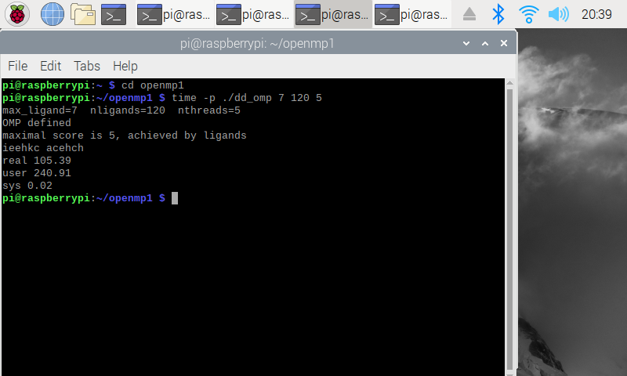Threads – 81.91s

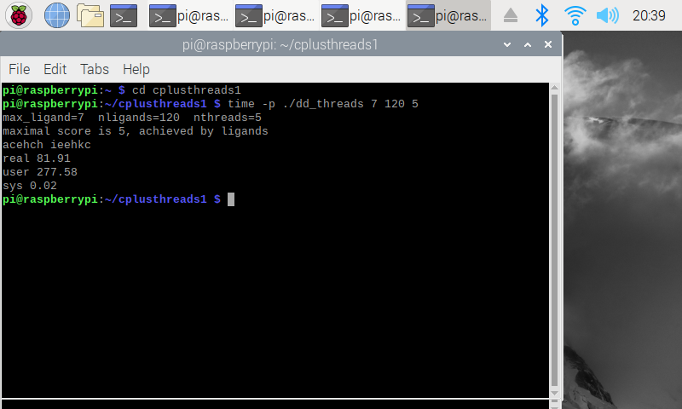

**Increase the maximum ligand length to 7, and rerun. What is runtime for each?**

See above images. They incorporate both the max_ligand size of 7 and 5 threads.